**Step 1: Downloading Android Studio for Windows**

Download android studio from official website

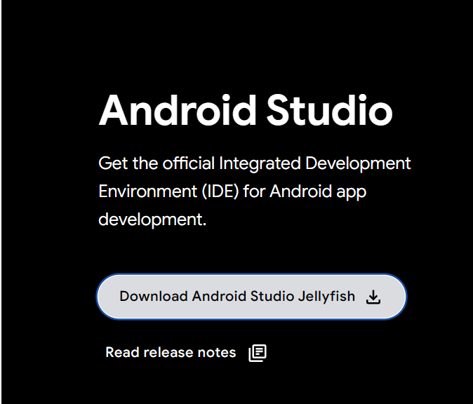

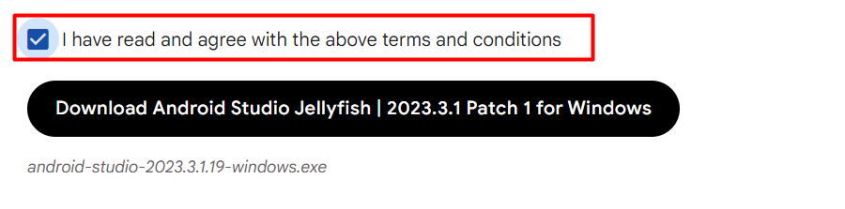

**Step 2: Start the Installer**

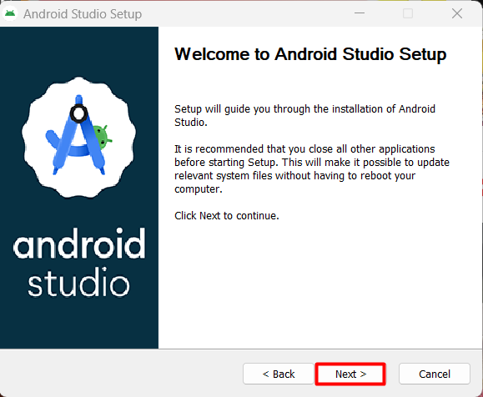

**Step 2: Choose Components**

The first step in the installation wizard is to Choose Components. By default, the only component selected is the Android Virtual Device, which is required for running and testing your Android apps on an emulator:

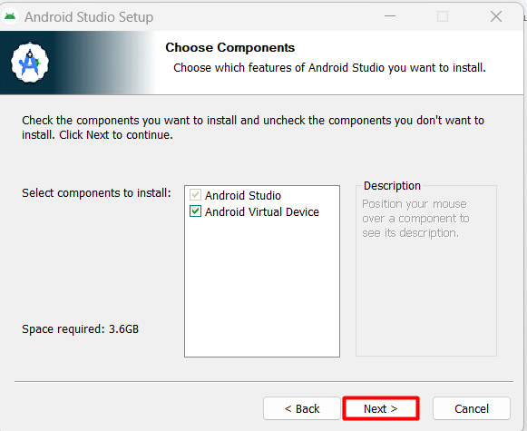

**Step 3: Choose the Installation Location and click next**

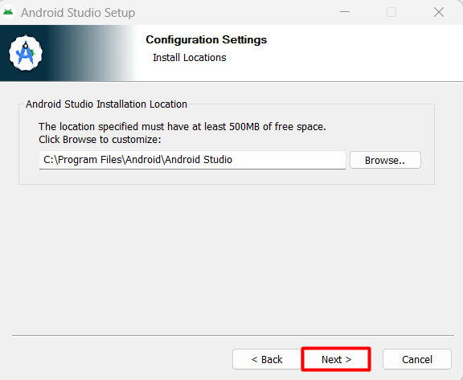

**Step 4: Choose the Start Menu Folder and Install**

**Click install**

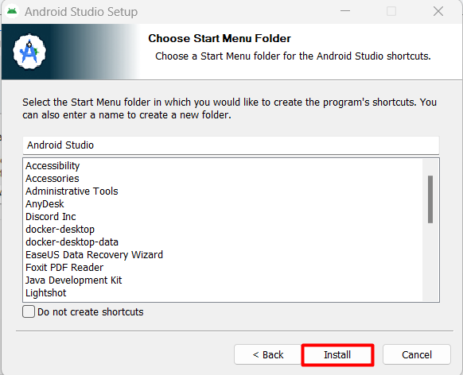

**Step 5: Complete the Installation**

**Click Finish**

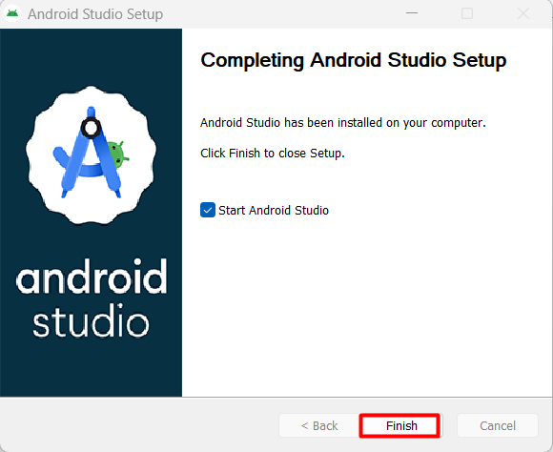

**Step 6: Import Android Studio Settings**

Select Do not import settings

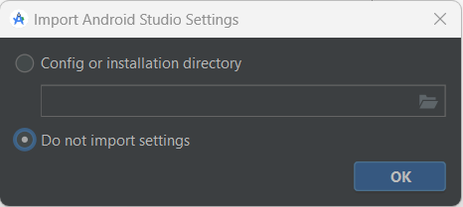

**Step 7: Choose Settings**

**Select standard and click on next**

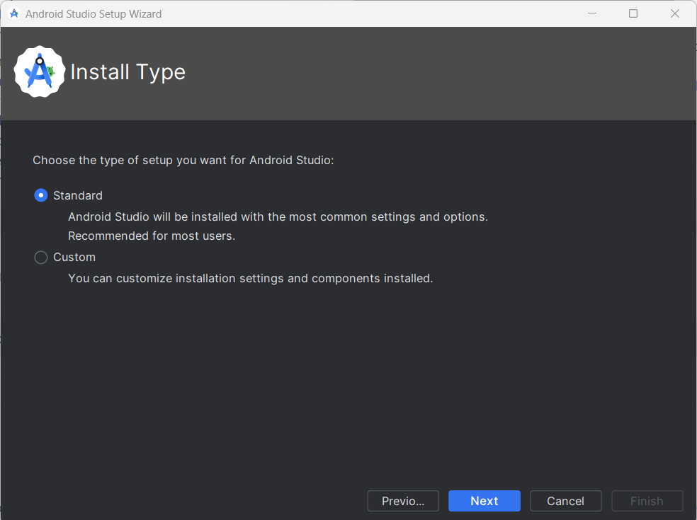

**Step 8: Accept License Agreement**

At the bottom of the screen, you’ll see a Finish button which will only be enabled if you accept the license agreement. Once you click Finish, the installation process will be complete, and Android Studio will be ready for use.

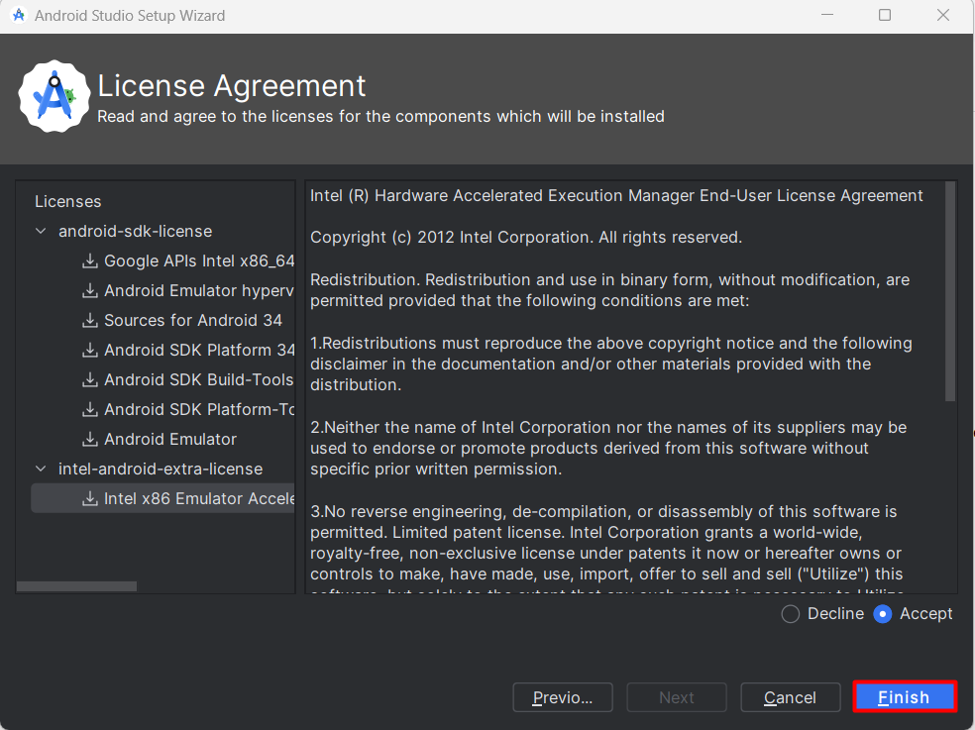

# Main Activity.java

*package* com.example.hellouniverse;  
  
*import* android.os.Bundle;  
  
*import* androidx.activity.EdgeToEdge;  
*import* androidx.appcompat.app.AppCompatActivity;  
*import* androidx.core.graphics.Insets;  
*import* androidx.core.view.ViewCompat;  
*import* androidx.core.view.WindowInsetsCompat;  
  
*public class* MainActivity *extends* AppCompatActivity {  
  
 @Override  
 *protected void* onCreate(Bundle savedInstanceState) {  
 *super*.onCreate(savedInstanceState);  
 EdgeToEdge.*enable*(*this*);  
 setContentView(R.layout.*activity_main*);  
 ViewCompat.*setOnApplyWindowInsetsListener*(findViewById(R.id.*main*), (v, insets) -> {  
 Insets systemBars = insets.getInsets(WindowInsetsCompat.Type.*systemBars*());  
 v.setPadding(systemBars.left, systemBars.top, systemBars.right, systemBars.bottom);  
 *return* insets;  
 });  
 }  
}

# Mainactivity.xml

*package* com.example.hellouniverse;  
  
*import* android.os.Bundle;  
  
*import* androidx.activity.EdgeToEdge;  
*import* androidx.appcompat.app.AppCompatActivity;  
*import* androidx.core.graphics.Insets;  
*import* androidx.core.view.ViewCompat;  
*import* androidx.core.view.WindowInsetsCompat;  
  
*public class* MainActivity *extends* AppCompatActivity {  
  
 @Override  
 *protected void* onCreate(Bundle savedInstanceState) {  
 *super*.onCreate(savedInstanceState);  
 EdgeToEdge.*enable*(*this*);  
 setContentView(R.layout.*activity_main*);  
 ViewCompat.*setOnApplyWindowInsetsListener*(findViewById(R.id.*main*), (v, insets) -> {  
 Insets systemBars = insets.getInsets(WindowInsetsCompat.Type.*systemBars*());  
 v.setPadding(systemBars.left, systemBars.top, systemBars.right, systemBars.bottom);  
 *return* insets;  
 });  
 }  
}

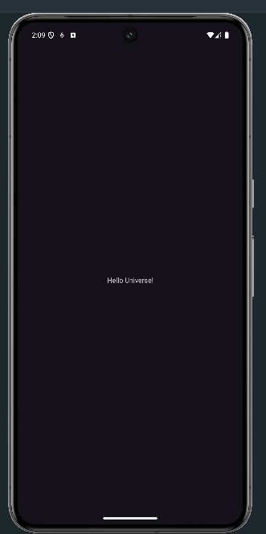

Assignment 2

# Main Activity.java

package com.example.loginreset;

import androidx.appcompat.app.AppCompatActivity;

import android.os.Bundle;

import android.view.View;

import android.widget.Button;

import android.widget.EditText;

import android.widget.TextView;

import com.example.loginreset.R;

public class MainActivity extends AppCompatActivity {

Button Submit,Reset;

EditText Email,Password;

TextView Result;

@Override

protected void onCreate(Bundle savedInstanceState) {

super.onCreate(savedInstanceState);

setContentView(R.layout.activity_main);

Submit=findViewById(R.id.Login);

Reset=findViewById(R.id.Reset);

Email=findViewById(R.id.Email);

Password=findViewById(R.id.Password);

Result=findViewById(R.id.Result);

Submit.setOnClickListener(new View.OnClickListener() {

@Override

public void onClick(View v) {

String email=Email.getText().toString();

String password=Password.getText().toString();

Result.setText("Email Id:"+email+"\nPassword: "+password);

}

});

Reset.setOnClickListener(new View.OnClickListener() {

@Override

public void onClick(View v) {

Email.setText("");

Password.setText("");

Result.setText("");

}

});

}

}

# Main Activity.xml

<?*xml version*="1.0" *encoding*="utf-8"?>  
<androidx.constraintlayout.widget.ConstraintLayout *xmlns:android*="http://schemas.android.com/apk/res/android"  
 *xmlns:app*="http://schemas.android.com/apk/res-auto"  
 *xmlns:tools*="http://schemas.android.com/tools"  
 *android:layout_width*="match_parent"  
 *android:layout_height*="match_parent"  
 *tools:context*=".MainActivity">  
  
 <Button  
 *android:id*="@+id/Reset"  
 *android:layout_width*="126dp"  
 *android:layout_height*="54dp"  
 *android:text*="Reset"  
 *android:textSize*="24sp"  
 *app:layout_constraintBottom_toBottomOf*="parent"  
 *app:layout_constraintEnd_toEndOf*="parent"  
 *app:layout_constraintHorizontal_bias*="0.852"  
 *app:layout_constraintStart_toStartOf*="parent"  
 *app:layout_constraintTop_toTopOf*="parent"  
 *app:layout_constraintVertical_bias*="0.475" />  
  
 <TextView  
 *android:id*="@+id/textView"  
 *android:layout_width*="278dp"  
 *android:layout_height*="89dp"  
 *android:text*="LOGIN ACTIVITY"  
 *android:textColor*="#ff0000"  
 *android:textSize*="34sp"  
 *android:textStyle*="bold"  
 *app:layout_constraintBottom_toBottomOf*="parent"  
 *app:layout_constraintEnd_toEndOf*="parent"  
 *app:layout_constraintHorizontal_bias*="0.496"  
 *app:layout_constraintStart_toStartOf*="parent"  
 *app:layout_constraintTop_toTopOf*="parent"  
 *app:layout_constraintVertical_bias*="0.096" />  
  
 <EditText  
 *android:id*="@+id/Email"  
 *android:layout_width*="wrap_content"  
 *android:layout_height*="wrap_content"  
 *android:ems*="10"  
 *android:inputType*="textEmailAddress"  
 *android:hint*=" Enter your Email"  
 *app:layout_constraintBottom_toBottomOf*="parent"  
 *app:layout_constraintEnd_toEndOf*="parent"  
 *app:layout_constraintHorizontal_bias*="0.666"  
 *app:layout_constraintStart_toStartOf*="parent"  
 *app:layout_constraintTop_toTopOf*="parent"  
 *app:layout_constraintVertical_bias*="0.263" />  
  
 <TextView  
 *android:id*="@+id/textView2"  
 *android:layout_width*="89dp"  
 *android:layout_height*="48dp"  
 *android:shadowColor*="#00F6F6F6"  
 *android:text*="EMAIL: "  
 *android:textColor*="#FF5722"  
 *android:textSize*="18sp"  
 *android:textStyle*="bold"  
 *app:layout_constraintBottom_toBottomOf*="parent"  
 *app:layout_constraintEnd_toEndOf*="parent"  
 *app:layout_constraintHorizontal_bias*="0.067"  
 *app:layout_constraintStart_toStartOf*="parent"  
 *app:layout_constraintTop_toTopOf*="parent"  
 *app:layout_constraintVertical_bias*="0.274" />  
  
 <TextView  
 *android:id*="@+id/textView3"  
 *android:layout_width*="92dp"  
 *android:layout_height*="46dp"  
 *android:shadowColor*="#00F6F6F6"  
 *android:text*="Password: "  
  
 *android:textColor*="#FF5722"  
 *android:textSize*="18sp"  
 *android:textStyle*="bold"  
 *app:layout_constraintBottom_toBottomOf*="parent"  
 *app:layout_constraintEnd_toEndOf*="parent"  
 *app:layout_constraintHorizontal_bias*="0.072"  
 *app:layout_constraintStart_toStartOf*="parent"  
 *app:layout_constraintTop_toTopOf*="parent"  
 *app:layout_constraintVertical_bias*="0.356" />  
  
 <EditText  
 *android:id*="@+id/Password"  
 *android:layout_width*="wrap_content"  
 *android:layout_height*="wrap_content"  
 *android:ems*="10"  
 *android:hint*="Enter Your Password"  
 *android:inputType*="textPassword"  
 *app:layout_constraintBottom_toBottomOf*="parent"  
 *app:layout_constraintEnd_toEndOf*="parent"  
 *app:layout_constraintHorizontal_bias*="0.666"  
 *app:layout_constraintStart_toStartOf*="parent"  
 *app:layout_constraintTop_toTopOf*="parent"  
 *app:layout_constraintVertical_bias*="0.357" />  
  
 <Button  
 *android:id*="@+id/Login"  
 *android:layout_width*="126dp"  
 *android:layout_height*="54dp"  
 *android:text*="Login"  
 *android:textSize*="24sp"  
 *app:layout_constraintBottom_toBottomOf*="parent"  
 *app:layout_constraintEnd_toEndOf*="parent"  
 *app:layout_constraintHorizontal_bias*="0.1"  
 *app:layout_constraintStart_toStartOf*="parent"  
 *app:layout_constraintTop_toTopOf*="parent"  
 *app:layout_constraintVertical_bias*="0.476" />  
  
 <TextView  
 *android:id*="@+id/Result"  
 *android:layout_width*="170dp"  
 *android:layout_height*="78dp"  
 *android:text*="TextView"  
 *app:layout_constraintBottom_toBottomOf*="parent"  
 *app:layout_constraintEnd_toEndOf*="parent"  
 *app:layout_constraintHorizontal_bias*="0.24"  
 *app:layout_constraintStart_toStartOf*="parent"  
 *app:layout_constraintTop_toTopOf*="parent"  
 *app:layout_constraintVertical_bias*="0.719" />  
</androidx.constraintlayout.widget.ConstraintLayout>

**OUTPUT:**

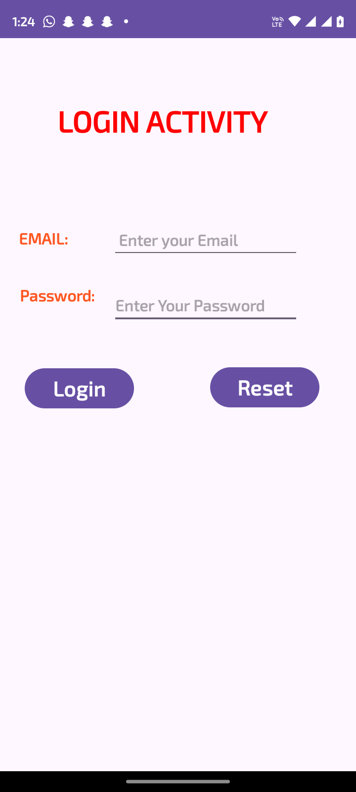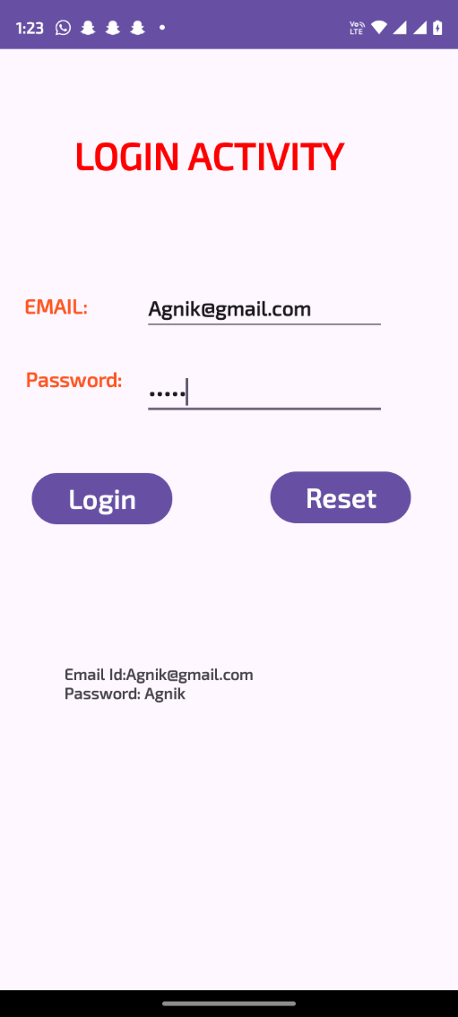

Assignment 3

**Create an application that takes the email and password from text box and shows a email and password entered in the text box when the user click submit button.**

* **activity_main.xml**

<?xml version="1.0" encoding="utf-8"?>

<LinearLayout xmlns:android="http://schemas.android.com/apk/res/android"

android:layout_width="match_parent"

android:layout_height="match_parent"

android:orientation="vertical"

android:padding="16dp">

<EditText

android:id="@+id/emailEditText"

android:layout_width="match_parent"

android:layout_height="wrap_content"

android:hint="Email"

android:inputType="textEmailAddress" />

<EditText

android:id="@+id/passwordEditText"

android:layout_width="match_parent"

android:layout_height="wrap_content"

android:hint="Password"

android:inputType="textPassword" />

<Button

android:id="@+id/submitButton"

android:layout_width="wrap_content"

android:layout_height="wrap_content"

android:text="Submit"

android:layout_marginTop="16dp"/>

<Button

android:id="@+id/resetButton"

android:layout_width="wrap_content"

android:layout_height="wrap_content"

android:text="Reset"

android:layout_marginTop="8dp"/>

<TextView

android:id="@+id/displayTextView"

android:layout_width="match_parent"

android:layout_height="wrap_content"

android:text=""

android:layout_marginTop="16dp"

android:textSize="18sp"/>

</LinearLayout>

* **MainActivity.java**

package com.example.uservalue;

import android.os.Bundle;

import android.view.View;

import android.widget.Button;

import android.widget.EditText;

import android.widget.TextView;

import androidx.appcompat.app.AppCompatActivity;

public class MainActivity extends AppCompatActivity {

private EditText emailEditText;

private EditText passwordEditText;

private TextView displayTextView;

@Override

protected void onCreate(Bundle savedInstanceState) {

super.onCreate(savedInstanceState);

setContentView(R.layout.activity_main);

emailEditText = findViewById(R.id.emailEditText);

passwordEditText = findViewById(R.id.passwordEditText);

displayTextView = findViewById(R.id.displayTextView);

Button submitButton = findViewById(R.id.submitButton);

Button resetButton = findViewById(R.id.resetButton);

submitButton.setOnClickListener(new View.OnClickListener() {

@Override

public void onClick(View v) {

String email = emailEditText.getText().toString();

String password = passwordEditText.getText().toString();

displayTextView.setText("Email: " + email + "\nPassword: " + password);

}

});

resetButton.setOnClickListener(new View.OnClickListener() {

@Override

public void onClick(View v) {

emailEditText.setText("");

passwordEditText.setText("");

displayTextView.setText("");

}

});

}

}

* **Output: -**

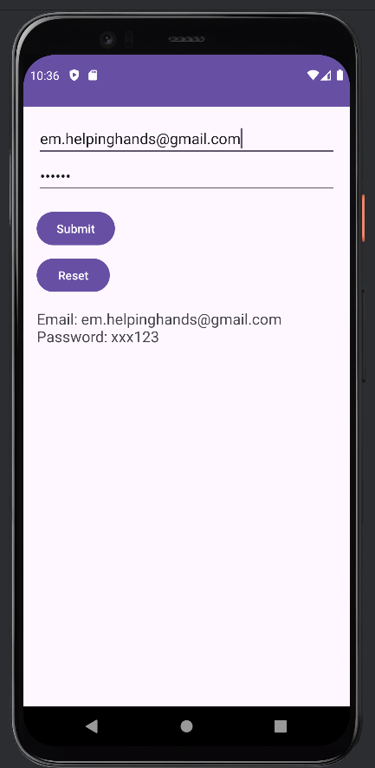

Assignment 4

**Create an Android app using ImageView to show a picture using Linear Layout and try to design a basic gallery.**

* **activity_main.xml**

<?xml version="1.0" encoding="utf-8"?>

<LinearLayout xmlns:android="http://schemas.android.com/apk/res/android"

xmlns:app="http://schemas.android.com/apk/res-auto"

xmlns:tools="http://schemas.android.com/tools"

android:id="@+id/main"

android:layout_width="match_parent"

android:layout_height="match_parent"

android:orientation="vertical"

tools:context=".MainActivity">

<ImageView

android:id="@+id/imageView"

android:layout_width="match_parent"

android:layout_height="151dp"

tools:srcCompat="@tools:sample/avatars" />

<RelativeLayout

android:layout_width="match_parent"

android:layout_height="314dp">

<Button

android:id="@+id/kochi_btn"

android:layout_width="125dp"

android:layout_height="73dp"

android:layout_alignParentStart="true"

android:layout_alignParentTop="true"

android:layout_alignParentEnd="true"

android:layout_alignParentBottom="true"

android:layout_marginStart="135dp"

android:layout_marginTop="10dp"

android:layout_marginEnd="150dp"

android:layout_marginBottom="231dp"

android:text="Kochi" />

<Button

android:id="@+id/doga_btn"

android:layout_width="125dp"

android:layout_height="73dp"

android:layout_alignParentStart="true"

android:layout_alignParentTop="true"

android:layout_alignParentEnd="true"

android:layout_alignParentBottom="true"

android:layout_marginStart="135dp"

android:layout_marginTop="85dp"

android:layout_marginEnd="150dp"

android:layout_marginBottom="156dp"

android:text="Doga" />

<Button

android:id="@+id/babu_btn"

android:layout_width="125dp"

android:layout_height="73dp"

android:layout_alignParentStart="true"

android:layout_alignParentTop="true"

android:layout_alignParentEnd="true"

android:layout_alignParentBottom="true"

android:layout_marginStart="135dp"

android:layout_marginTop="161dp"

android:layout_marginEnd="150dp"

android:layout_marginBottom="80dp"

android:text="Babu" />

<Button

android:id="@+id/reset_btn"

android:layout_width="125dp"

android:layout_height="73dp"

android:layout_alignParentStart="true"

android:layout_alignParentTop="true"

android:layout_alignParentEnd="true"

android:layout_alignParentBottom="true"

android:layout_marginStart="135dp"

android:layout_marginTop="237dp"

android:layout_marginEnd="150dp"

android:layout_marginBottom="4dp"

android:text="NO IMG" />

</RelativeLayout>

<LinearLayout

android:layout_width="match_parent"

android:layout_height="match_parent"

android:orientation="vertical">

<TextView

android:id="@+id/kochi_txt"

android:layout_width="match_parent"

android:layout_height="32dp"

android:text="Number of time hit Kochi" />

<TextView

android:id="@+id/kochi_ct"

android:layout_width="match_parent"

android:layout_height="32dp"

android:text="0" />

<TextView

android:id="@+id/doga_txt"

android:layout_width="match_parent"

android:layout_height="32dp"

android:text="Number of time hit Doga" />

<TextView

android:id="@+id/doga_ct"

android:layout_width="match_parent"

android:layout_height="32dp"

android:text="0" />

<TextView

android:id="@+id/babu_txt"

android:layout_width="match_parent"

android:layout_height="32dp"

android:text="Number of time hit Babu" />

<TextView

android:id="@+id/babu_ct"

android:layout_width="match_parent"

android:layout_height="32dp"

android:text="0" />

</LinearLayout>

</LinearLayout>

* **MainActivity.java**

package com.example.imageview;

import androidx.appcompat.app.AppCompatActivity;

import android.os.Bundle;

import android.view.View;

import android.widget.Button;

import android.widget.ImageView;

import android.widget.TextView;

public class MainActivity extends AppCompatActivity {

Button btn_kochi, btn_doga, btn_babu, btn_reset;

ImageView img;

TextView ct_kochi, ct_doga, ct_babu;

private int kochiCount = 0;

private int dogaCount = 0;

private int babuCount = 0;

@Override

protected void onCreate(Bundle savedInstanceState) {

super.onCreate(savedInstanceState);

setContentView(R.layout.activity_main);

img = findViewById(R.id.imageView);

btn_kochi = findViewById(R.id.kochi_btn);

btn_doga = findViewById(R.id.doga_btn);

btn_babu = findViewById(R.id.babu_btn);

btn_reset = findViewById(R.id.reset_btn);

ct_kochi= findViewById(R.id.kochi_ct);

ct_doga= findViewById(R.id.doga_ct);

ct_babu = findViewById(R.id.babu_ct);

// Set initial text for counters

ct_babu.setText(String.valueOf(babuCount));

ct_doga.setText(String.valueOf(dogaCount));

ct_babu.setText(String.valueOf(babuCount));

// Button click listener for Kochi

btn_kochi.setOnClickListener(new View.OnClickListener() {

@Override

public void onClick(View v) {

img.setImageResource(R.drawable.kochi);

kochiCount++;

ct_kochi.setText(String.valueOf(kochiCount));

}

});

// Button click listener for Doga

btn_doga.setOnClickListener(new View.OnClickListener() {

@Override

public void onClick(View v) {

img.setImageResource(R.drawable.doga);

dogaCount++;

ct_doga.setText(String.valueOf(dogaCount));

}

});

// Button click listener for Babu

btn_babu.setOnClickListener(new View.OnClickListener() {

@Override

public void onClick(View v) {

img.setImageResource(R.drawable.babu);

babuCount++;

ct_babu.setText(String.valueOf(babuCount));

}

});

// Button click listener for Reset

btn_reset.setOnClickListener(new View.OnClickListener() {

@Override

public void onClick(View v) {

img.setImageResource(R.drawable.nojpg);

kochiCount = 0;

dogaCount = 0;

babuCount = 0;

ct_kochi.setText(String.valueOf(kochiCount));

ct_doga.setText(String.valueOf(dogaCount));

ct_babu.setText(String.valueOf(babuCount));

}

});

}

}

* **Output: -**

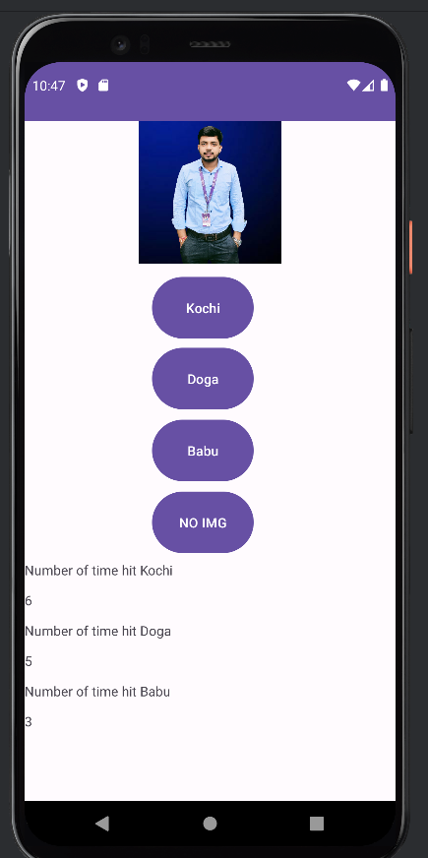

Assignment 5

1. **Create an Android app to add and subtract two numbers supplied from the user interface having two text boxes.**
2. **Create an Android app to multiply and divide two numbers supplied from the user interface having two text boxes.**

* **activity_main.xml**

<?xml version="1.0" encoding="utf-8"?>

<LinearLayout xmlns:android="http://schemas.android.com/apk/res/android"

xmlns:app="http://schemas.android.com/apk/res-auto"

xmlns:tools="http://schemas.android.com/tools"

android:layout_width="match_parent"

android:orientation="vertical"

android:layout_height="match_parent"

tools:context=".MainActivity">

<TextView

android:id="@+id/textView3"

android:layout_width="match_parent"

android:layout_height="wrap_content"

android:background="#FBEAEB"

android:textSize="40sp"

android:text="MiNi calculator"

android:textAlignment="center"/>

<EditText

android:id="@+id/editTextText"

android:layout_width="match_parent"

android:layout_height="wrap_content"

android:layout_marginBottom="20dp"

android:ems="10"

android:inputType="numberDecimal"

android:hint="Enter first value" />

<EditText

android:id="@+id/editTextText2"

android:layout_width="match_parent"

android:layout_height="wrap_content"

android:layout_marginBottom="20dp"

android:ems="10"

android:inputType="numberDecimal"

android:hint="Enter second value" />

<LinearLayout

android:layout_width="match_parent"

android:layout_height="wrap_content"

android:layout_margin="20dp"

android:orientation="horizontal">

<Button

android:id="@+id/button2"

android:layout_width="0dp"

android:layout_height="wrap_content"

android:layout_weight="1"

android:text="+" />

<Button

android:id="@+id/button3"

android:layout_width="0dp"

android:layout_height="wrap_content"

android:layout_weight="1"

android:text="-" />

<Button

android:id="@+id/button4"

android:layout_width="0dp"

android:layout_height="wrap_content"

android:layout_weight="1"

android:text="*" />

<Button

android:id="@+id/button5"

android:layout_width="0dp"

android:layout_height="wrap_content"

android:layout_weight="1"

android:text="/" />

</LinearLayout>

<TextView

android:id="@+id/textView4"

android:textSize="40sp"

android:layout_width="match_parent"

android:layout_height="wrap_content"

android:background="#2F3C7E"

android:text="Result="

android:textColor="#ff0000"

android:textStyle="bold"/>

</LinearLayout>

* **MainActivity.java**

package com.example.calculator;

import androidx.appcompat.app.AppCompatActivity;

import android.os.Bundle;

import android.view.View;

import android.widget.Button;

import android.widget.EditText;

import android.widget.TextView;

import android.widget.Toast;

public class MainActivity extends AppCompatActivity {

private EditText editText1, editText2;

private TextView resultTextView;

private Button addButton, subtractButton, multiplyButton, divideButton;

@Override

protected void onCreate(Bundle savedInstanceState) {

super.onCreate(savedInstanceState);

setContentView(R.layout.activity_main);

// Initialize UI elements

editText1 = findViewById(R.id.editTextText);

editText2 = findViewById(R.id.editTextText2);

resultTextView = findViewById(R.id.textView4);

addButton = findViewById(R.id.button2);

subtractButton = findViewById(R.id.button3);

multiplyButton = findViewById(R.id.button4);

divideButton = findViewById(R.id.button5);

// Set listeners for buttons

addButton.setOnClickListener(new View.OnClickListener() {

@Override

public void onClick(View v) {

performOperation('+');

}

});

subtractButton.setOnClickListener(new View.OnClickListener() {

@Override

public void onClick(View v) {

performOperation('-');

}

});

multiplyButton.setOnClickListener(new View.OnClickListener() {

@Override

public void onClick(View v) {

performOperation('*');

}

});

divideButton.setOnClickListener(new View.OnClickListener() {

@Override

public void onClick(View v) {

performOperation('/');

}

});

}

private void performOperation(char operator) {

String input1 = editText1.getText().toString();

String input2 = editText2.getText().toString();

if (input1.isEmpty() || input2.isEmpty()) {

Toast.makeText(this, "Please enter both values", Toast.LENGTH_SHORT).show();

return;

}

try {

double value1 = Double.parseDouble(input1);

double value2 = Double.parseDouble(input2);

double result = 0;

switch (operator) {

case '+':

result = value1 + value2;

break;

case '-':

result = value1 - value2;

break;

case '*':

result = value1 * value2;

break;

case '/':

if (value2 != 0) {

result = value1 / value2;

result = Math.round(result * 100.0) / 100.0;

} else {

Toast.makeText(this, "Cannot divide by zero", Toast.LENGTH_SHORT).show();

return;

}

break;

}

resultTextView.setText("Result = " + result);

} catch (NumberFormatException e) {

Toast.makeText(this, "Invalid input", Toast.LENGTH_SHORT).show();

}

}

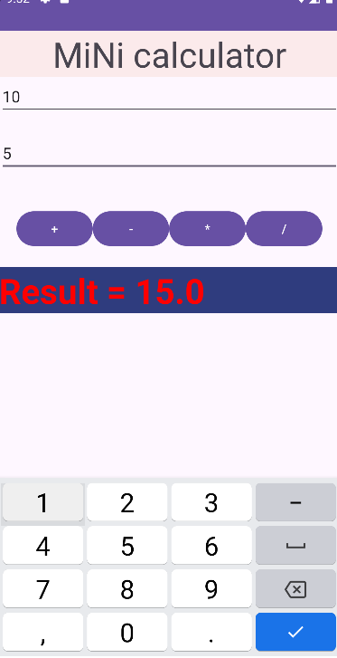}

* **Output: -**

Assignment 6

**a. Create a screen that has input boxes for User Name, Password, Address, Gender (radio buttons for male and female), Age (numeric), Date of Birth (Date Picker), State (Spinner), and a Submit button. On clicking the submit button, print all the data below the Submit Button (use any layout).**

* **activity_main.xml**

<?xml version="1.0" encoding="utf-8"?>

<LinearLayout

xmlns:android="http://schemas.android.com/apk/res/android"

android:layout_width="match_parent"

android:layout_height="match_parent"

android:orientation="vertical"

android:padding="16dp">

<EditText

android:id="@+id/username"

android:layout_width="match_parent"

android:layout_height="wrap_content"

android:hint="User Name" />

<EditText

android:id="@+id/password"

android:layout_width="match_parent"

android:layout_height="wrap_content"

android:hint="Password"

android:inputType="textPassword" />

<EditText

android:id="@+id/address"

android:layout_width="match_parent"

android:layout_height="wrap_content"

android:hint="Address" />

<TextView

android:layout_width="wrap_content"

android:layout_height="wrap_content"

android:text="Gender" />

<RadioGroup

android:id="@+id/gender"

android:layout_width="match_parent"

android:layout_height="wrap_content"

android:orientation="horizontal">

<RadioButton

android:id="@+id/male"

android:layout_width="wrap_content"

android:layout_height="wrap_content"

android:text="Male" />

<RadioButton

android:id="@+id/female"

android:layout_width="wrap_content"

android:layout_height="wrap_content"

android:text="Female" />

</RadioGroup>

<EditText

android:id="@+id/age"

android:layout_width="match_parent"

android:layout_height="wrap_content"

android:hint="Age"

android:inputType="number" />

<TextView

android:layout_width="wrap_content"

android:layout_height="wrap_content"

android:text="Date of Birth" />

<EditText

android:id="@+id/dob"

android:layout_width="match_parent"

android:layout_height="wrap_content"

android:hint="Select Date of Birth"

android:focusable="false"

android:clickable="true" />

<Spinner

android:id="@+id/state"

android:layout_width="match_parent"

android:layout_height="wrap_content" />

<Button

android:id="@+id/submit_button"

android:layout_width="match_parent"

android:layout_height="wrap_content"

android:text="Submit" />

<Button

android:id="@+id/reset_button"

android:layout_width="match_parent"

android:layout_height="wrap_content"

android:text="Reset" />

<TextView

android:id="@+id/output"

android:layout_width="match_parent"

android:layout_height="wrap_content"

android:paddingTop="16dp" />

</LinearLayout>

* **strings.xml**

<resources>

<string name="app_name">USER VALUE</string>

<string-array name="states_array">

<item>Select State</item>

<item>WEST BENGAL</item>

<item>TAMILNADU</item>

<item>ODISHA</item>

<item>MUMBAI</item>

<item>CHENNAI</item>

</string-array>

</resources>

* **MainActivity.java**

package com.example.uservalue;

import android.app.DatePickerDialog;

import android.os.Bundle;

import android.view.View;

import android.widget.ArrayAdapter;

import android.widget.Button;

import android.widget.EditText;

import android.widget.RadioButton;

import android.widget.RadioGroup;

import android.widget.Spinner;

import android.widget.TextView;

import androidx.annotation.NonNull;

import androidx.appcompat.app.AppCompatActivity;

import java.util.Calendar;

public class MainActivity extends AppCompatActivity {

private EditText username, password, address, age, dob;

private RadioGroup gender;

private Spinner state;

private Button submitButton, resetButton;

private TextView output;

@Override

protected void onCreate(Bundle savedInstanceState) {

super.onCreate(savedInstanceState);

setContentView(R.layout.activity_main);

username = findViewById(R.id.username);

password = findViewById(R.id.password);

address = findViewById(R.id.address);

age = findViewById(R.id.age);

dob = findViewById(R.id.dob);

gender = findViewById(R.id.gender);

state = findViewById(R.id.state);

submitButton = findViewById(R.id.submit_button);

resetButton = findViewById(R.id.reset_button);

output = findViewById(R.id.output);

ArrayAdapter<CharSequence> adapter = ArrayAdapter.createFromResource(this,

R.array.states_array, android.R.layout.simple_spinner_item);

adapter.setDropDownViewResource(android.R.layout.simple_spinner_dropdown_item);

state.setAdapter(adapter);

dob.setOnClickListener(v -> {

Calendar calendar = Calendar.getInstance();

int year = calendar.get(Calendar.YEAR);

int month = calendar.get(Calendar.MONTH);

int day = calendar.get(Calendar.DAY_OF_MONTH);

DatePickerDialog datePickerDialog = new DatePickerDialog(MainActivity.this,

(view, selectedYear, selectedMonth, selectedDay) -> {

dob.setText(selectedDay + "/" + (selectedMonth + 1) + "/" + selectedYear);

}, year, month, day);

datePickerDialog.show();

});

submitButton.setOnClickListener(v -> {

String userName = username.getText().toString();

String userPassword = password.getText().toString();

String userAddress = address.getText().toString();

String userAge = age.getText().toString();

String userDob = dob.getText().toString();

String userState = state.getSelectedItem().toString();

String userGender = ((RadioButton) findViewById(gender.getCheckedRadioButtonId())).getText().toString();

output.setText("User Name: " + userName + "\n" +

"Password: " + userPassword + "\n" +

"Address: " + userAddress + "\n" +

"Gender: " + userGender + "\n" +

"Age: " + userAge + "\n" +

"Date of Birth: " + userDob + "\n" +

"State: " + userState);

});

resetButton.setOnClickListener(v -> {

username.setText("");

password.setText("");

address.setText("");

age.setText("");

dob.setText("");

gender.clearCheck(); // Clears the selected radio button

state.setSelection(0); // Resets the spinner to the first item

output.setText(""); // Clears the output TextView

});

}

}

* **Output: -**

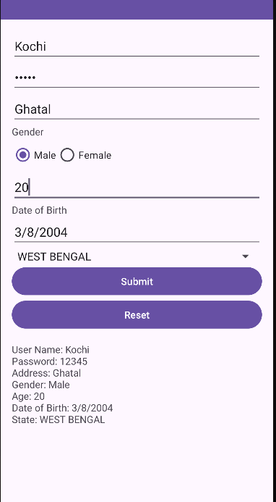

**b. Create an Android app that will check whether the given number supplied as an input is prime or not.**

* **activity_main.xml**

<?xml version="1.0" encoding="utf-8"?>

<RelativeLayout xmlns:android="http://schemas.android.com/apk/res/android"

android:layout_width="match_parent"

android:layout_height="match_parent"

android:padding="16dp">

<EditText

android:id="@+id/numberInput"

android:layout_width="match_parent"

android:layout_height="wrap_content"

android:hint="Enter a number"

android:inputType="number" />

<Button

android:id="@+id/checkButton"

android:layout_width="wrap_content"

android:layout_height="wrap_content"

android:text="Check Prime"

android:layout_below="@id/numberInput"

android:layout_marginTop="16dp" />

<TextView

android:id="@+id/resultText"

android:layout_width="match_parent"

android:layout_height="wrap_content"

android:layout_below="@id/checkButton"

android:layout_marginTop="16dp"

android:textSize="18sp" />

</RelativeLayout>

* **MainActivity.java**

package com.example.primechecker;

import androidx.appcompat.app.AppCompatActivity;

import android.os.Bundle;

import android.view.View;

import android.widget.Button;

import android.widget.EditText;

import android.widget.TextView;

public class MainActivity extends AppCompatActivity {

private EditText numberInput;

private Button checkButton;

private TextView resultText;

@Override

protected void onCreate(Bundle savedInstanceState) {

super.onCreate(savedInstanceState);

setContentView(R.layout.activity_main);

numberInput = findViewById(R.id.numberInput);

checkButton = findViewById(R.id.checkButton);

resultText = findViewById(R.id.resultText);

checkButton.setOnClickListener(new View.OnClickListener() {

@Override

public void onClick(View view) {

String input = numberInput.getText().toString();

if (!input.isEmpty()) {

int number = Integer.parseInt(input);

boolean isPrime = isPrime(number);

resultText.setText(number + " is " + (isPrime ? "a prime number." : "not a prime number."));

} else {

resultText.setText("Please enter a valid number.");

}

}

});

}

private boolean isPrime(int num) {

if (num <= 1) return false;

for (int i = 2; i <= Math.sqrt(num); i++) {

if (num % i == 0) {

return false;

}

}

return true;

}

}

* **Output: -**

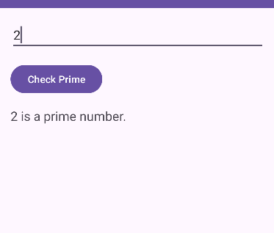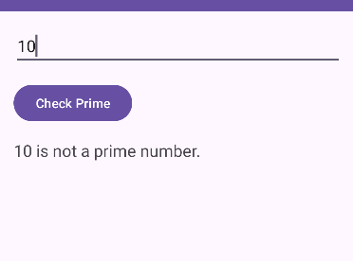

**c. Create an Android app that will check whether given two numbers are palindrome or not.**

* **activity_main.xml**

<?xml version="1.0" encoding="utf-8"?>

<RelativeLayout xmlns:android="http://schemas.android.com/apk/res/android"

android:layout_width="match_parent"

android:layout_height="match_parent"

android:padding="16dp">

<EditText

android:id="@+id/firstNumberInput"

android:layout_width="match_parent"

android:layout_height="wrap_content"

android:hint="Enter the first number"

android:inputType="number" />

<EditText

android:id="@+id/secondNumberInput"

android:layout_width="match_parent"

android:layout_height="wrap_content"

android:hint="Enter the second number"

android:layout_below="@id/firstNumberInput"

android:layout_marginTop="16dp"

android:inputType="number" />

<Button

android:id="@+id/checkButton"

android:layout_width="wrap_content"

android:layout_height="wrap_content"

android:text="Check Palindrome"

android:layout_below="@id/secondNumberInput"

android:layout_marginTop="16dp" />

<TextView

android:id="@+id/resultText"

android:layout_width="match_parent"

android:layout_height="wrap_content"

android:layout_below="@id/checkButton"

android:layout_marginTop="16dp"

android:textSize="18sp" />

</RelativeLayout>

* **MainActivity.java**

package com.example.palindromechecker;

import androidx.appcompat.app.AppCompatActivity;

import android.os.Bundle;

import android.view.View;

import android.widget.Button;

import android.widget.EditText;

import android.widget.TextView;

public class MainActivity extends AppCompatActivity {

private EditText firstNumberInput;

private EditText secondNumberInput;

private Button checkButton;

private TextView resultText;

@Override

protected void onCreate(Bundle savedInstanceState) {

super.onCreate(savedInstanceState);

setContentView(R.layout.activity_main);

firstNumberInput = findViewById(R.id.firstNumberInput);

secondNumberInput = findViewById(R.id.secondNumberInput);

checkButton = findViewById(R.id.checkButton);

resultText = findViewById(R.id.resultText);

checkButton.setOnClickListener(new View.OnClickListener() {

@Override

public void onClick(View view) {

String firstInput = firstNumberInput.getText().toString();

String secondInput = secondNumberInput.getText().toString();

if (!firstInput.isEmpty() && !secondInput.isEmpty()) {

boolean isFirstPalindrome = isPalindrome(firstInput);

boolean isSecondPalindrome = isPalindrome(secondInput);

resultText.setText("First Number: " + firstInput + " is " + (isFirstPalindrome ? "a palindrome." : "not a palindrome.") +

"\nSecond Number: " + secondInput + " is " + (isSecondPalindrome ? "a palindrome." : "not a palindrome."));

} else {

resultText.setText("Please enter valid numbers.");

}

}

});

}

private boolean isPalindrome(String number) {

String reversed = new StringBuilder(number).reverse().toString();

return number.equals(reversed);

}

}

* **Output: -**

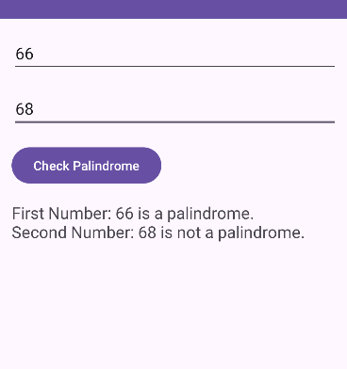

Assignment 7

|  |
| --- |
| **a. Create an Android app to show and implement table layout.** |

|  |  |
| --- | --- |
| **b. Develop an Android Application that can calculate the sum of digits of a given number.** |  |

* **activity_main.xml**

<?xml version="1.0" encoding="utf-8"?>

<RelativeLayout xmlns:android="http://schemas.android.com/apk/res/android"

android:layout_width="match_parent"

android:layout_height="match_parent"

android:padding="16dp">

<TableLayout

android:layout_width="match_parent"

android:layout_height="wrap_content">

<TableRow>

<TextView

android:layout_width="wrap_content"

android:layout_height="wrap_content"

android:text="Enter a number:"

android:padding="8dp" />

<EditText

android:id="@+id/numberInput"

android:layout_width="0dp"

android:layout_height="wrap_content"

android:layout_weight="1"

android:hint="Number"

android:inputType="number" />

</TableRow>

<TableRow>

<Button

android:id="@+id/calculateButton"

android:layout_width="wrap_content"

android:layout_height="wrap_content"

android:text="Calculate Sum" />

</TableRow>

<TableRow>

<TextView

android:id="@+id/resultText"

android:layout_width="match_parent"

android:layout_height="wrap_content"

android:layout_marginTop="16dp"

android:textSize="18sp" />

</TableRow>

</TableLayout>

</RelativeLayout>

* **MainActivity.java**

package com.example.sumofdigitstablelayout;

import androidx.appcompat.app.AppCompatActivity;

import android.os.Bundle;

import android.view.View;

import android.widget.Button;

import android.widget.EditText;

import android.widget.TextView;

public class MainActivity extends AppCompatActivity {

private EditText numberInput;

private Button calculateButton;

private TextView resultText;

@Override

protected void onCreate(Bundle savedInstanceState) {

super.onCreate(savedInstanceState);

setContentView(R.layout.activity_main);

numberInput = findViewById(R.id.numberInput);

calculateButton = findViewById(R.id.calculateButton);

resultText = findViewById(R.id.resultText);

calculateButton.setOnClickListener(new View.OnClickListener() {

@Override

public void onClick(View view) {

String input = numberInput.getText().toString();

if (!input.isEmpty()) {

int sum = calculateSumOfDigits(input);

resultText.setText("Sum of digits: " + sum);

} else {

resultText.setText("Please enter a valid number.");

}

}

});

}

private int calculateSumOfDigits(String number) {

int sum = 0;

for (char digit : number.toCharArray()) {

sum += Character.getNumericValue(digit);

}

return sum;

}

}

* **Output: -**

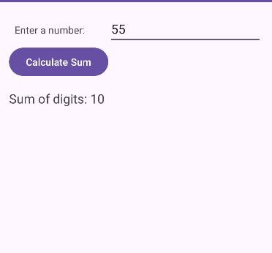

Assignment 8

**Write an android app to develop a calculator with basic operations.**

* **activity_main.xml**

<?xml version="1.0" encoding="utf-8"?>

<LinearLayout xmlns:android="http://schemas.android.com/apk/res/android"

xmlns:app="http://schemas.android.com/apk/res-auto"

xmlns:tools="http://schemas.android.com/tools"

android:layout_width="match_parent"

android:orientation="vertical"

android:layout_height="match_parent"

tools:context=".MainActivity">

<TextView

android:id="@+id/textView3"

android:layout_width="match_parent"

android:layout_height="wrap_content"

android:background="#FBEAEB"

android:textSize="40sp"

android:text="MiNi calculator"

android:textAlignment="center"/>

<EditText

android:id="@+id/editTextText"

android:layout_width="match_parent"

android:layout_height="wrap_content"

android:layout_marginBottom="20dp"

android:ems="10"

android:inputType="numberDecimal"

android:hint="Enter first value" />

<EditText

android:id="@+id/editTextText2"

android:layout_width="match_parent"

android:layout_height="wrap_content"

android:layout_marginBottom="20dp"

android:ems="10"

android:inputType="numberDecimal"

android:hint="Enter second value" />

<LinearLayout

android:layout_width="match_parent"

android:layout_height="wrap_content"

android:layout_margin="20dp"

android:orientation="horizontal">

<Button

android:id="@+id/button2"

android:layout_width="0dp"

android:layout_height="wrap_content"

android:layout_weight="1"

android:text="+" />

<Button

android:id="@+id/button3"

android:layout_width="0dp"

android:layout_height="wrap_content"

android:layout_weight="1"

android:text="-" />

<Button

android:id="@+id/button4"

android:layout_width="0dp"

android:layout_height="wrap_content"

android:layout_weight="1"

android:text="*" />

<Button

android:id="@+id/button5"

android:layout_width="0dp"

android:layout_height="wrap_content"

android:layout_weight="1"

android:text="/" />

</LinearLayout>

<TextView

android:id="@+id/textView4"

android:textSize="40sp"

android:layout_width="match_parent"

android:layout_height="wrap_content"

android:background="#2F3C7E"

android:text="Result="

android:textColor="#ff0000"

android:textStyle="bold"/>

</LinearLayout>

* **MainActivity.java**

package com.example.calculator;

import androidx.appcompat.app.AppCompatActivity;

import android.os.Bundle;

import android.view.View;

import android.widget.Button;

import android.widget.EditText;

import android.widget.TextView;

import android.widget.Toast;

public class MainActivity extends AppCompatActivity {

private EditText editText1, editText2;

private TextView resultTextView;

private Button addButton, subtractButton, multiplyButton, divideButton;

@Override

protected void onCreate(Bundle savedInstanceState) {

super.onCreate(savedInstanceState);

setContentView(R.layout.activity_main);

// Initialize UI elements

editText1 = findViewById(R.id.editTextText);

editText2 = findViewById(R.id.editTextText2);

resultTextView = findViewById(R.id.textView4);

addButton = findViewById(R.id.button2);

subtractButton = findViewById(R.id.button3);

multiplyButton = findViewById(R.id.button4);

divideButton = findViewById(R.id.button5);

// Set listeners for buttons

addButton.setOnClickListener(new View.OnClickListener() {

@Override

public void onClick(View v) {

performOperation('+');

}

});

subtractButton.setOnClickListener(new View.OnClickListener() {

@Override

public void onClick(View v) {

performOperation('-');

}

});

multiplyButton.setOnClickListener(new View.OnClickListener() {

@Override

public void onClick(View v) {

performOperation('*');

}

});

divideButton.setOnClickListener(new View.OnClickListener() {

@Override

public void onClick(View v) {

performOperation('/');

}

});

}

private void performOperation(char operator) {

String input1 = editText1.getText().toString();

String input2 = editText2.getText().toString();

if (input1.isEmpty() || input2.isEmpty()) {

Toast.makeText(this, "Please enter both values", Toast.LENGTH_SHORT).show();

return;

}

try {

double value1 = Double.parseDouble(input1);

double value2 = Double.parseDouble(input2);

double result = 0;

switch (operator) {

case '+':

result = value1 + value2;

break;

case '-':

result = value1 - value2;

break;

case '*':

result = value1 * value2;

break;

case '/':

if (value2 != 0) {

result = value1 / value2;

result = Math.round(result * 100.0) / 100.0;

} else {

Toast.makeText(this, "Cannot divide by zero", Toast.LENGTH_SHORT).show();

return;

}

break;

}

resultTextView.setText("Result = " + result);

} catch (NumberFormatException e) {

Toast.makeText(this, "Invalid input", Toast.LENGTH_SHORT).show();

}

}

}

* **Output: -**



Assignment 9

**Create an android app that will check whether given username and password matches with the predefined user name and password.**

* **activity_main.xml**

<?xml version="1.0" encoding="utf-8"?>

<?xml version="1.0" encoding="utf-8"?>  
<LinearLayout xmlns:android="http://schemas.android.com/apk/res/android"  
 xmlns:app="http://schemas.android.com/apk/res-auto"  
 xmlns:tools="http://schemas.android.com/tools"  
 android:layout_width="match_parent"  
 android:layout_height="match_parent"  
 android:orientation="vertical"  
 android:layout_margin="15dp"  
 tools:context=".MainActivity">  
  
  
 <TextView  
 android:id="@+id/tvProfileDetails"  
 android:layout_width="match_parent"  
 android:layout_height="35dp"  
 android:text=" " />  
  
 <TextView  
 android:id="@+id/tvProfileName"  
 android:layout_width="match_parent"  
 android:layout_height="35dp"  
 android:text="Name" />  
  
 <TextView  
 android:id="@+id/tvProfileEmail"  
 android:layout_width="match_parent"  
 android:layout_height="40dp"  
 android:text="Email" />  
  
 <TextView  
 android:id="@+id/tvProfilePhone"  
 android:layout_width="match_parent"  
 android:layout_height="33dp"  
 android:text="Phone" />  
  
 <TextView  
 android:id="@+id/tvProfileAddress"  
 android:layout_width="match_parent"  
 android:layout_height="32dp"  
 android:text="Address" />  
  
 <Button  
 android:id="@+id/btnLogout"  
 android:layout_width="match_parent"  
 android:layout_height="wrap_content"  
 android:text="Logout" />  
</LinearLayout>

* **MainActivity.java**

package com.example.userform;

import androidx.appcompat.app.AppCompatActivity;

import android.annotation.SuppressLint;

import android.content.Intent;

import android.os.Bundle;

import android.view.View;

import android.widget.Button;

import android.widget.TextView;

public class MainActivity extends AppCompatActivity {

TextView tvProfileDetails, tvProfileName, tvProfileEmail, tvProfilePhone, tvProfileAddress;

Button btnLogout;

@SuppressLint("MissingInflatedId")

@Override

protected void onCreate(Bundle savedInstanceState) {

super.onCreate(savedInstanceState);

setContentView(R.layout.activity_main);

tvProfileDetails = findViewById(R.id.tvProfileDetails);

tvProfileName = findViewById(R.id.tvProfileName);

tvProfileEmail = findViewById(R.id.tvProfileEmail);

tvProfilePhone = findViewById(R.id.tvProfilePhone);

tvProfileAddress = findViewById(R.id.tvProfileAddress);

btnLogout = findViewById(R.id.btnLogout);

com.example.registrationapp.User user = REGISTRATION.registeredUser;

if (user != null) {

tvProfileDetails.setText("Welcome to " +user.getName() + "r village...");

tvProfileName.setText("Name: " + user.getName());

tvProfileEmail.setText("Email: " + user.getEmail());

tvProfilePhone.setText("Phone: " + user.getPhone());

tvProfileAddress.setText("Address: " + user.getAddress());

}

btnLogout.setOnClickListener(new View.OnClickListener() {

@Override

public void onClick(View view) {

Intent intent = new Intent(MainActivity.this, LOGIN.class);

startActivity(intent);

finish(); // close profile activity

}

});

}

}

* **activity_login.xml**

<?xml version="1.0" encoding="utf-8"?>

<LinearLayout xmlns:android="http://schemas.android.com/apk/res/android"

xmlns:tools="http://schemas.android.com/tools"

android:layout_width="match_parent"

android:layout_height="match_parent"

android:orientation="vertical"

android:layout_margin="15dp"

tools:context=".LOGIN">

<EditText

android:id="@+id/etLoginEmail"

android:layout_width="match_parent"

android:layout_height="wrap_content"

android:hint="Email" />

<EditText

android:id="@+id/etLoginPassword"

android:layout_width="match_parent"

android:layout_height="wrap_content"

android:hint="Password"

android:inputType="textPassword" />

<Button

android:id="@+id/btnLogin"

android:layout_width="match_parent"

android:layout_height="wrap_content"

android:text="Login" />

<Button

android:id="@+id/btnSignUp"

android:layout_width="match_parent"

android:layout_height="wrap_content"

android:text="Sign Up" />

</LinearLayout>

* **LOGIN.java**

package com.example.userform;

import androidx.appcompat.app.AppCompatActivity;

import android.annotation.SuppressLint;

import android.content.Intent;

import android.os.Bundle;

import android.view.View;

import android.widget.Button;

import android.widget.EditText;

import android.widget.Toast;

public class LOGIN extends AppCompatActivity {

EditText etLoginEmail, etLoginPassword;

Button btnLogin, btnSignUp;

@SuppressLint("MissingInflatedId")

@Override

protected void onCreate(Bundle savedInstanceState) {

super.onCreate(savedInstanceState);

setContentView(R.layout.activity_login);

etLoginEmail = findViewById(R.id.etLoginEmail);

etLoginPassword = findViewById(R.id.etLoginPassword);

btnLogin = findViewById(R.id.btnLogin);

btnSignUp = findViewById(R.id.btnSignUp);

btnLogin.setOnClickListener(new View.OnClickListener() {

@Override

public void onClick(View view) {

String email = etLoginEmail.getText().toString();

String password = etLoginPassword.getText().toString();

if (REGISTRATION.registeredUser != null) {

if (email.equals(REGISTRATION.registeredUser.getEmail()) && password.equals(REGISTRATION.registeredUser.getPassword())) {

Intent intent = new Intent(LOGIN.this, MainActivity.class);

startActivity(intent);

} else {

Toast.makeText(LOGIN.this, "Invalid credentials", Toast.LENGTH_SHORT).show();

}

} else {

Toast.makeText(LOGIN.this, "No registered user", Toast.LENGTH_SHORT).show();

}

}

});

btnSignUp.setOnClickListener(new View.OnClickListener() {

@Override

public void onClick(View view) {

Intent intent = new Intent(LOGIN.this, REGISTRATION.class);

startActivity(intent);

}

});

}

}

* **activity_registration.xml**

<?xml version="1.0" encoding="utf-8"?>

<LinearLayout xmlns:android="http://schemas.android.com/apk/res/android"

xmlns:tools="http://schemas.android.com/tools"

android:layout_width="match_parent"

android:orientation="vertical"

android:layout_margin="15dp"

android:layout_height="match_parent"

tools:context=".REGISTRATION">

<EditText

android:id="@+id/etName"

android:layout_width="match_parent"

android:layout_height="wrap_content"

android:hint="Name" />

<EditText

android:id="@+id/etEmail"

android:layout_width="match_parent"

android:layout_height="wrap_content"

android:hint="Email"

android:inputType="textEmailAddress" />

<EditText

android:id="@+id/etPassword"

android:layout_width="match_parent"

android:layout_height="wrap_content"

android:hint="Password"

android:inputType="textPassword" />

<EditText

android:id="@+id/etPhone"

android:layout_width="match_parent"

android:layout_height="wrap_content"

android:hint="Phone"

android:inputType="phone" />

<EditText

android:id="@+id/etAddress"

android:layout_width="match_parent"

android:layout_height="wrap_content"

android:hint="Address" />

<Button

android:id="@+id/btnRegister"

android:layout_width="match_parent"

android:layout_height="wrap_content"

android:text="Register" />

<Button

android:id="@+id/btnToLogin"

android:layout_width="match_parent"

android:layout_height="wrap_content"

android:text="Go to Login" />

</LinearLayout>

* **REGISTRATION.java**

package com.example.userform;

import androidx.annotation.RequiresApi;

import androidx.appcompat.app.AppCompatActivity;

import android.annotation.SuppressLint;

import android.content.Intent;

import android.os.Build;

import android.os.Bundle;

import android.os.Handler;

import android.view.View;

import android.widget.Button;

import android.widget.EditText;

import android.widget.Toast;

import com.example.registrationapp.User;

public class REGISTRATION extends AppCompatActivity {

EditText etName, etEmail, etPassword, etPhone, etAddress;

Button btnRegister, btnToLogin;

static com.example.registrationapp.User registeredUser;

@SuppressLint("WrongViewCast")

@Override

protected void onCreate(Bundle savedInstanceState) {

super.onCreate(savedInstanceState);

setContentView(R.layout.activity_registration);

etName = findViewById(R.id.etName);

etEmail = findViewById(R.id.etEmail);

etPassword = findViewById(R.id.etPassword);

etPhone = findViewById(R.id.etPhone);

etAddress = findViewById(R.id.etAddress);

btnRegister = findViewById(R.id.btnRegister);

btnToLogin = findViewById(R.id.btnToLogin);

btnRegister.setOnClickListener(new View.OnClickListener() {

@Override

public void onClick(View view) {

String name = etName.getText().toString();

String email = etEmail.getText().toString();

String password = etPassword.getText().toString();

String phone = etPhone.getText().toString();

String address = etAddress.getText().toString();

if (!name.isEmpty() && !email.isEmpty() && !password.isEmpty()) {

registeredUser = new User(name, email, password, phone, address);

Toast.makeText(REGISTRATION.this, "Registration Successful!", Toast.LENGTH_SHORT).show();

} else {

Toast.makeText(REGISTRATION.this, "Please fill all fields", Toast.LENGTH_SHORT).show();

}

}

});

btnToLogin.setOnClickListener(new View.OnClickListener() {

@Override

public void onClick(View view) {

startActivity(new Intent(REGISTRATION.this, LOGIN.class));

}

});

}

}

* **Output: -**

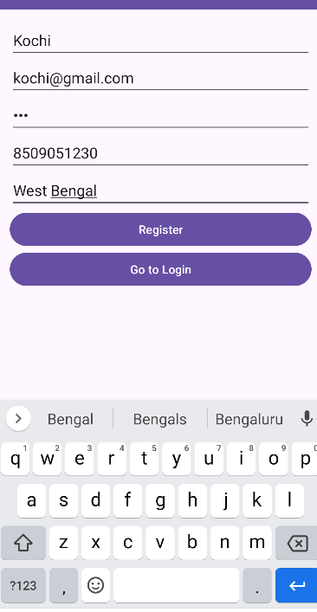

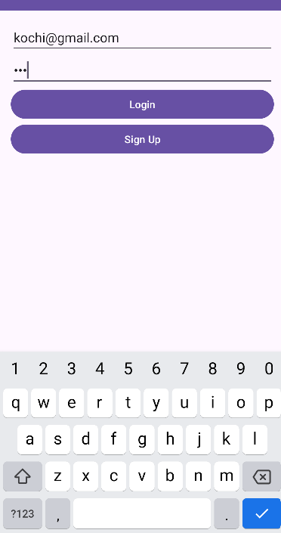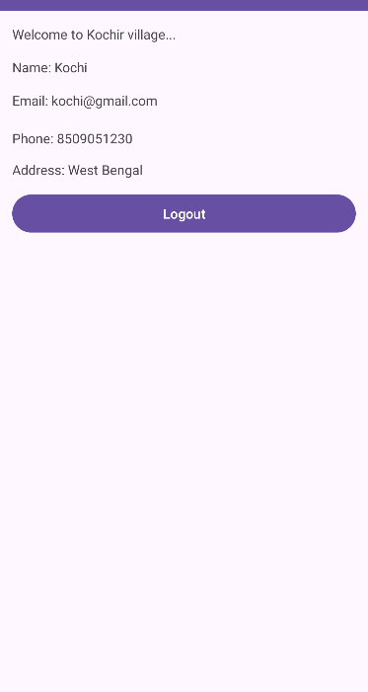

Assignments 10

**Create an android application demonstrating Toast, Intent etc.**

* **activity_main.xml**

<?xml version="1.0" encoding="utf-8"?>

<LinearLayout xmlns:android="http://schemas.android.com/apk/res/android"

xmlns:app="http://schemas.android.com/apk/res-auto"

xmlns:tools="http://schemas.android.com/tools"

android:id="@+id/main"

android:layout_width="match_parent"

android:orientation="vertical"

android:layout_margin="20dp"

android:background="@drawable/img_1"

android:layout_height="match_parent"

tools:context=".MainActivity">

<EditText

android:id="@+id/edittext_name_xml"

android:layout_width="match_parent"

android:layout_height="wrap_content"

android:ems="10"

android:inputType="text"

android:textSize="25dp"

android:hint="Name" />

<EditText

android:id="@+id/edittext_email_xml"

android:layout_width="match_parent"

android:layout_height="wrap_content"

android:ems="10"

android:textSize="25dp"

android:hint="Email"

android:inputType="textEmailAddress" />

<EditText

android:id="@+id/edittext_phone_xml"

android:layout_width="match_parent"

android:layout_height="wrap_content"

android:ems="10"

android:hint="Phone"

android:textSize="25dp"

android:inputType="phone" />

<EditText

android:id="@+id/edittext_password_xml"

android:layout_width="match_parent"

android:layout_height="wrap_content"

android:ems="10"

android:hint="Password"

android:textSize="25dp"

android:inputType="textPassword" />

<Button

android:id="@+id/btn_login_xml"

android:layout_width="match_parent"

android:layout_height="wrap_content"

android:text="Login 🔑" />

</LinearLayout>

* **MainActivity.java**

package com.example.intentapplication;

import android.content.Intent;

import android.os.Bundle;

import android.os.Handler;

import android.view.View;

import android.widget.Button;

import android.widget.EditText;

import android.widget.Toast;

import androidx.activity.EdgeToEdge;

import androidx.appcompat.app.AppCompatActivity;

import androidx.core.graphics.Insets;

import androidx.core.view.ViewCompat;

import androidx.core.view.WindowInsetsCompat;

public class MainActivity extends AppCompatActivity {

private EditText txt_name, txt_email, txt_password, txt_phone;

private Button button_login;

@Override

protected void onCreate(Bundle savedInstanceState) {

super.onCreate(savedInstanceState);

EdgeToEdge.enable(this);

setContentView(R.layout.activity_main);

// Initialize views

txt_name = findViewById(R.id.edittext_name_xml);

txt_email = findViewById(R.id.edittext_email_xml);

txt_phone = findViewById(R.id.edittext_phone_xml);

txt_password = findViewById(R.id.edittext_password_xml);

button_login = findViewById(R.id.btn_login_xml);

// Apply window insets for edge-to-edge experience

ViewCompat.setOnApplyWindowInsetsListener(findViewById(R.id.main), (v, insets) -> {

Insets systemBars = insets.getInsets(WindowInsetsCompat.Type.systemBars());

v.setPadding(systemBars.left, systemBars.top, systemBars.right, systemBars.bottom);

return insets;

});

// Set button click listener

button_login.setOnClickListener(new View.OnClickListener() {

@Override

public void onClick(View view) {

String name_first = txt_name.getText().toString();

String email_first = txt_email.getText().toString();

String phone_first = txt_phone.getText().toString();

String password_first = txt_password.getText().toString();

Toast.makeText(MainActivity.this, "Kochi is Loading....", Toast.LENGTH_SHORT).show();

new Handler().postDelayed(new Runnable() {

@Override

public void run() {

Intent intent = new Intent(MainActivity.this, display.class);

intent.putExtra("name_intent", name_first);

intent.putExtra("email_intent", email_first);

intent.putExtra("phone_intent", phone_first);

intent.putExtra("password_intent", password_first);

startActivity(intent);

}

}, 2000);

}

});

}

}

* **activity_display.xml**

<?xml version="1.0" encoding="utf-8"?>

<LinearLayout xmlns:android="http://schemas.android.com/apk/res/android"

xmlns:app="http://schemas.android.com/apk/res-auto"

xmlns:tools="http://schemas.android.com/tools"

android:id="@+id/main"

android:layout_width="match_parent"

android:orientation="vertical"

android:layout_margin="25dp"

android:layout_height="match_parent"

tools:context=".display">

<TextView

android:id="@+id/textview_name_xml"

android:layout_width="match_parent"

android:layout_height="36dp"

android:textSize="25dp"

android:textStyle="bold"

android:text="Name:" />

<TextView

android:id="@+id/textview_email_xml"

android:layout_width="match_parent"

android:layout_height="36dp"

android:text="Email:"

android:textSize="25dp"

android:textStyle="bold" />

<TextView

android:id="@+id/textview_phone_xml"

android:layout_width="match_parent"

android:layout_height="36dp"

android:text="Phone:"

android:textSize="25dp"

android:textStyle="bold" />

<TextView

android:id="@+id/textview_password_xml"

android:layout_width="match_parent"

android:layout_height="36dp"

android:text="Password:"

android:textSize="25dp"

android:textStyle="bold" />

<Button

android:id="@+id/btn_back_xml"

android:layout_width="match_parent"

android:layout_height="wrap_content"

android:text="Back" />

</LinearLayout>

* **display.java**

package com.example.intentapplication;

import android.content.Intent;

import android.os.Bundle;

import android.view.View;

import android.widget.Button;

import android.widget.TextView;

import androidx.activity.EdgeToEdge;

import androidx.appcompat.app.AppCompatActivity;

import androidx.core.graphics.Insets;

import androidx.core.view.ViewCompat;

import androidx.core.view.WindowInsetsCompat;

public class display extends AppCompatActivity {

private TextView txt_name, txt_email, txt_password, txt_phone;

private Button button_back;

@Override

protected void onCreate(Bundle savedInstanceState) {

super.onCreate(savedInstanceState);

EdgeToEdge.enable(this);

setContentView(R.layout.activity_display);

// Initialize views

txt_name = findViewById(R.id.textview_name_xml);

txt_email = findViewById(R.id.textview_email_xml);

txt_phone = findViewById(R.id.textview_phone_xml);

txt_password = findViewById(R.id.textview_password_xml);

button_back = findViewById(R.id.btn_back_xml);

// Apply window insets for edge-to-edge experience

ViewCompat.setOnApplyWindowInsetsListener(findViewById(R.id.main), (v, insets) -> {

Insets systemBars = insets.getInsets(WindowInsetsCompat.Type.systemBars());

v.setPadding(systemBars.left, systemBars.top, systemBars.right, systemBars.bottom);

return insets;

});

// Get the intent data

String name_second = getIntent().getStringExtra("name_intent");

String email_second = getIntent().getStringExtra("email_intent");

String phone_second = getIntent().getStringExtra("phone_intent");

String password_second = getIntent().getStringExtra("password_intent");

// Set the text views with the received data

txt_name.setText("Name: " + name_second);

txt_email.setText("Email: " + email_second);

txt_phone.setText("Phone: " + phone_second);

txt_password.setText("Password: " + password_second);

// Set the button click listener

button_back.setOnClickListener(new View.OnClickListener() {

@Override

public void onClick(View v) {

// Clear text views

txt_name.setText("Name:");

txt_email.setText("Email:");

txt_phone.setText("Phone:");

txt_password.setText("Password:");

// Navigate back to MainActivity

Intent intent = new Intent(display.this, MainActivity.class);

startActivity(intent);

finish();

}

});

}

}

* **Output: -**

